**PROJECT REPORT**

**ON**

**QUIZ GAME**

**BY**

**Ghanshyam Zurange, Akash Pardeshi**

**Vivek Para, Naresh Choudhary**

**Under the Guidance of**

**Dr.Shivani Budhkar**

**MASTER IN COMPUTER APPLICATION**

**P.E.S’S MODERN COLLEGE OF ENGINEERING**

**PUNE – 411 005.**

**SAVITRIBAI PHULE PUNE UNIVERSITY**

**2020-21**

**Progressive Education Society’s**

**Modern College of Engineering, Pune- 411005**

**MCA Department**

**CERTIFICATE**

This is to certify that **GHANSHYAM ZURANGE, AKASH PARDESHI, VIVEK PARA, NARESH CHOUDHARY** of Master in computer Application have successfully completed the Project Based Learning work titled **‘QUIZ GAME’** during the academic year 2020-21.This report is submitted as partial fulfillment of the requirement of the said subject of Savitribai Phule Pune University.

**Dr. Mrs. K. R. Joshi Dr.Pradnya Muley Dr.Shivani Budhkar**

**Principal Head of Department Project Guide**

**ACKNOWLEDGEMENT**

We have taken efforts in this project. However it would not have been possible without the kind support and help of many individuals. We would like to extend our sincere thanks to all of them.

We are highly indebted to **Progressive Education Society’s Modern College of Engineering, MCA Department** for their guidance and constant supervision as well as for providing necessary information regarding the project and also their support in completing the project.

We would like to express our gratitude towards the guidance of **Dr.Shivani Budhkar** & faculty member for their kind co-operation and encouragement which help us in completion of this project.

We would like to express our special gratitude and thanks to my team mates without team work the project was out of bound.

Our thanks and appreciations also go to our college in developing the project and people who have willingly helped us out with their abilities.

**Ghanshyam Zurange(51067)**

**Akash Pardeshi(51043)**

**Vivek Para(51041)**

**Naresh Choudhary(51008)**

**INDEX**

**TITLE PAGE.NO**

**CHAPTER 1 : INTRODUCTION**

1.1 Introduction of Project 1

1.2 Need for System 1

1.3 Scope of Work 2

1.4 Operating Environment – Hardware and Software 3

**CHAPTER 2 : ANALYSIS & DESIGN**

2.1 Flow Diagram/chart 4

2.2 Database storage 5

2.3 Use case Diagram 7

2.4 Module Specifications 8

2.5 User Interface Design ( Screen Layouts) 9

**CHAPTER 3 : FUTURE SCOPE AND LIMITATION 13**

**CHAPTER 4 : CONCLUSION 14**

**CHAPTER 5 : BIBLIOGRAPHY 15**

**1.Introduction**

**1.1 Introduction of Project**

1. Quiz Game is a real-time Android Application. Developed for multiple users from different domains to challenge their knowledge.
2. This application provides a facility to play online quizzes.
3. It provides a good platform, where a user  not only improves their knowledge/skill but also they can have fun at the same time.

**1.2 Need for System**

* 1. Due to the current pandemic situation, all the major exams are conducted in MCQ format.
  2. Students can get familiar with the MCQ format by using QuizGame.
  3. Also, users can have fun and challenge their knowledge.

**1.3 Scope of Work**

The scope of this project is very broad in terms of gaining knowledge and sharing knowledge among the world.

**Few important points:**

* 1. Can be used anywhere, anytime as it is a mobile application.
  2. This app can be used in educational institutes as well as the corporate world.
  3. It is a flexible app, with a wide range of categories of Quiz.

**Functionality of Product:**

* Account Login:-

This is the first screen visible to the user after opening the app. Through this user can register themselves on our app. They need to provide some basic information like name, email id and password.

* Account Logout:-

User can logout the account whenever required.

* Leaderboard:-

A leaderboard is maintained where all the users are ranked on the basis of the coins they have earned.

* Play Quiz:-

In the app the user can play the quiz of his/her choice from the categories. While playing quiz if the user wants to quit then he can press quit button. The result is displayed immediately after the quiz is over. There are 4 options for each question with one correct answer.

* Wallet:-

After the user collects 50,000 or more coins then he/she can send request to withdraw money. They can provide their upi id and send their withdraw request.

**1.4 Operating Environment – Hardware and Software**

**Developer Specifications :**

* **H/W Specifications:**
* 8 GB RAM
* i5 processor 8th generation
* **S/W Specifications:**
* Windows 10
* Android Studio (For Application development)
* Database tool- No SQL(Firebase)

**User Specifications :**

* **H/W Specifications:**
* 2 GB RAM (Minimum)
* Hard Disk : 100 MB (Minimum)
* **S/W Specifications:**
* Android 4.4 and above

**2 . ANALYSIS & DESIGN**

**2.1 Flow Diagram/chart**

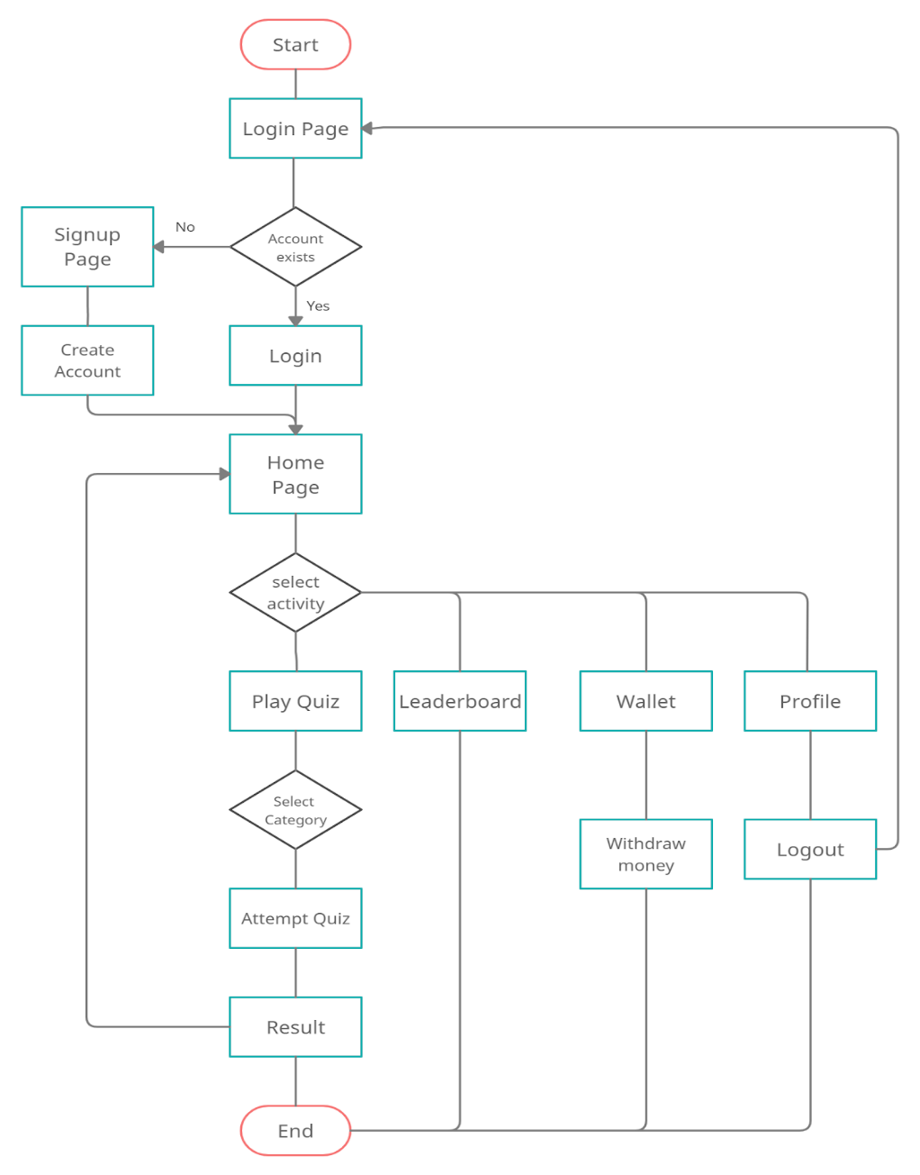

**2.2 Database storage**

USER: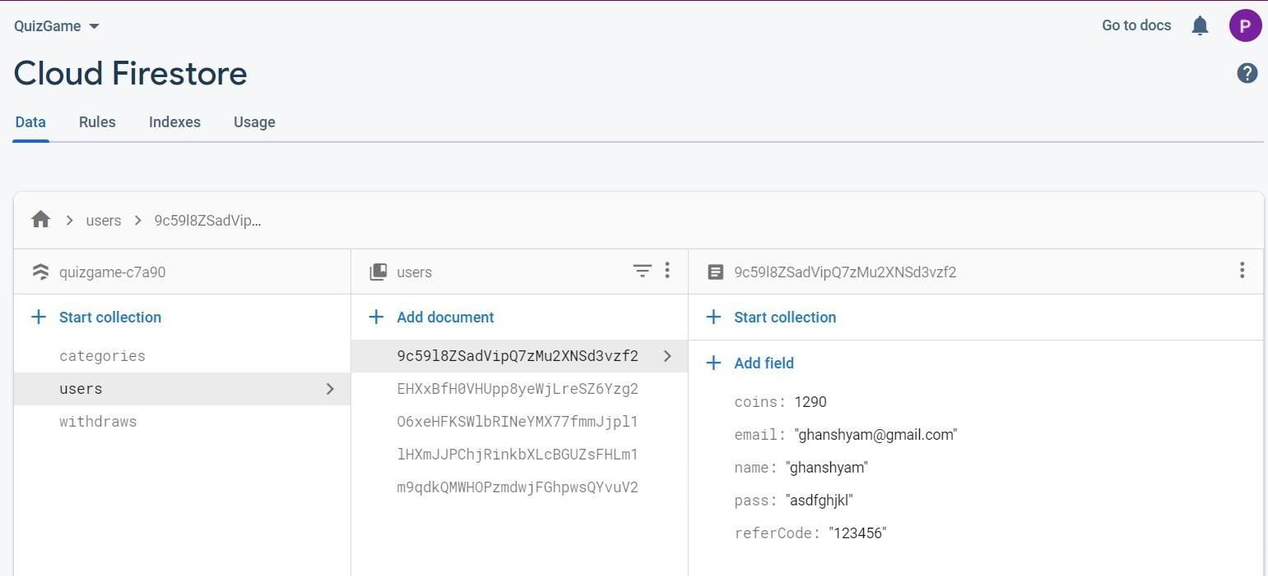

CATEGORIES:

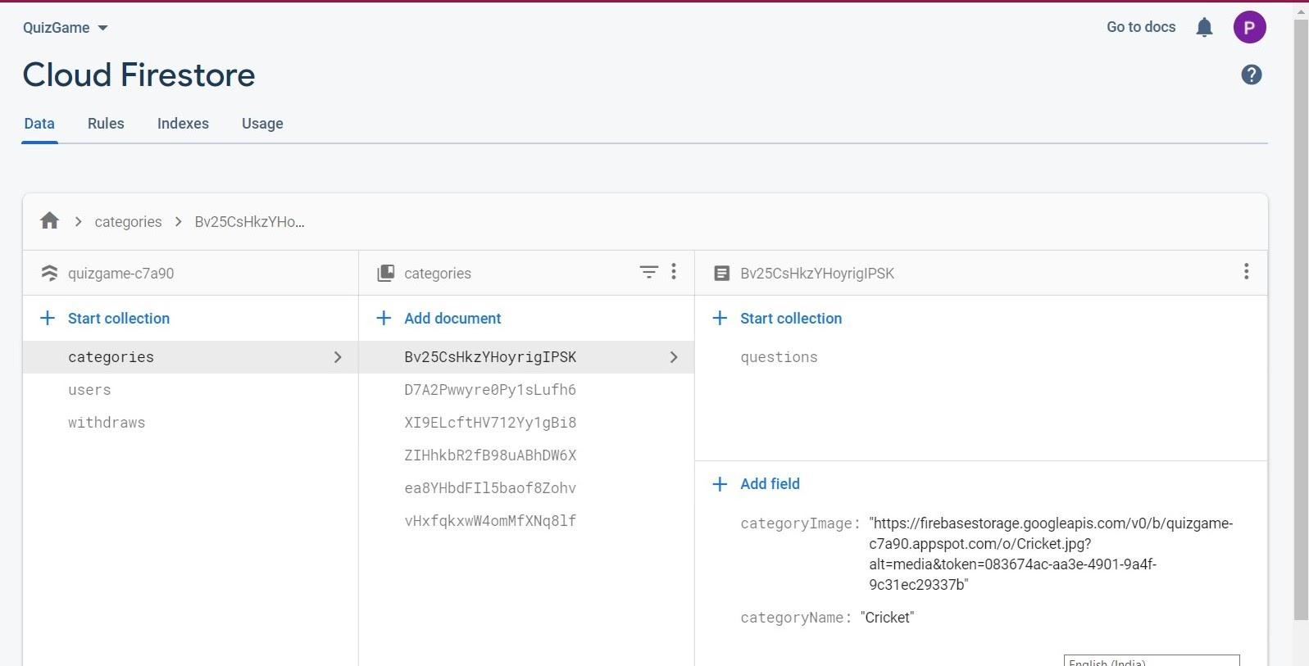

QUESTIONS:

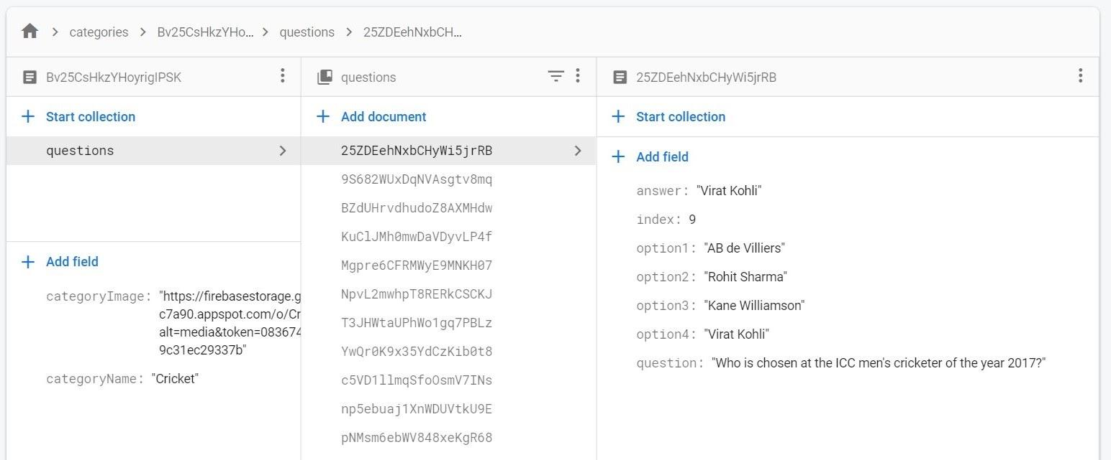

WITHDRAW:

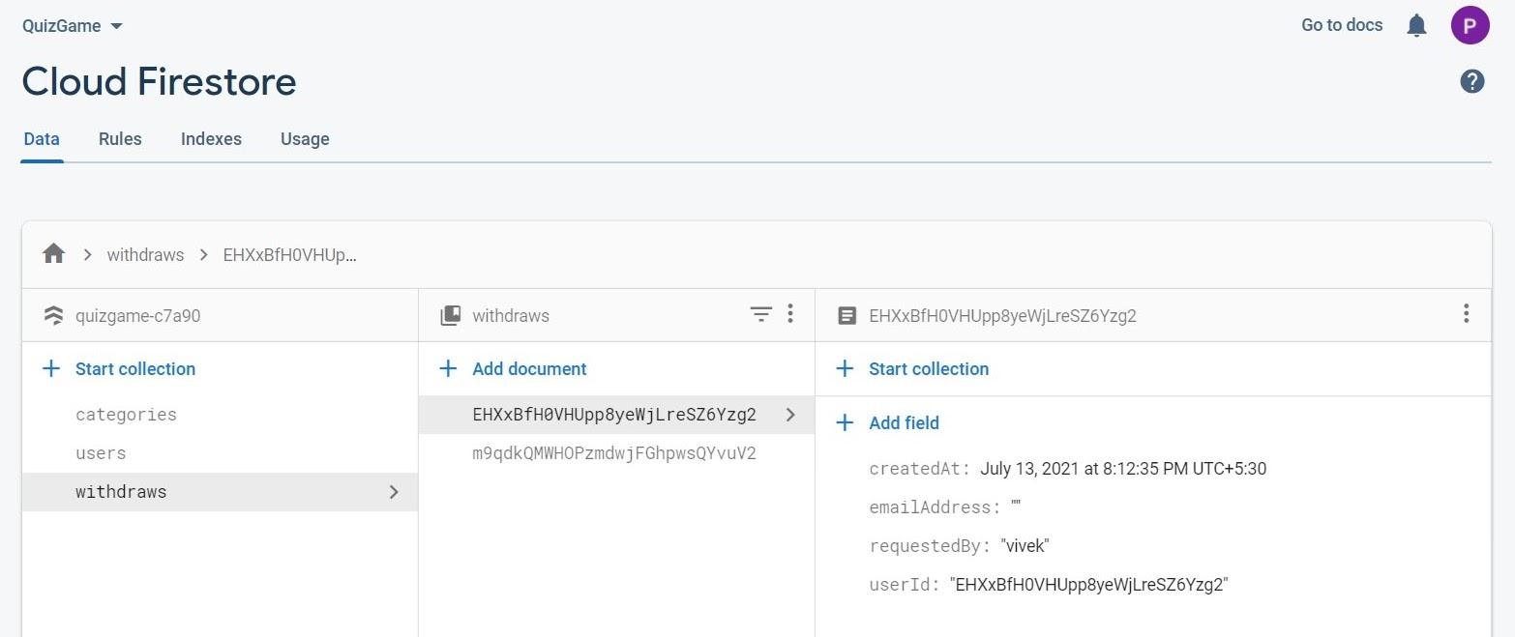

**2.3 Use case Diagram**

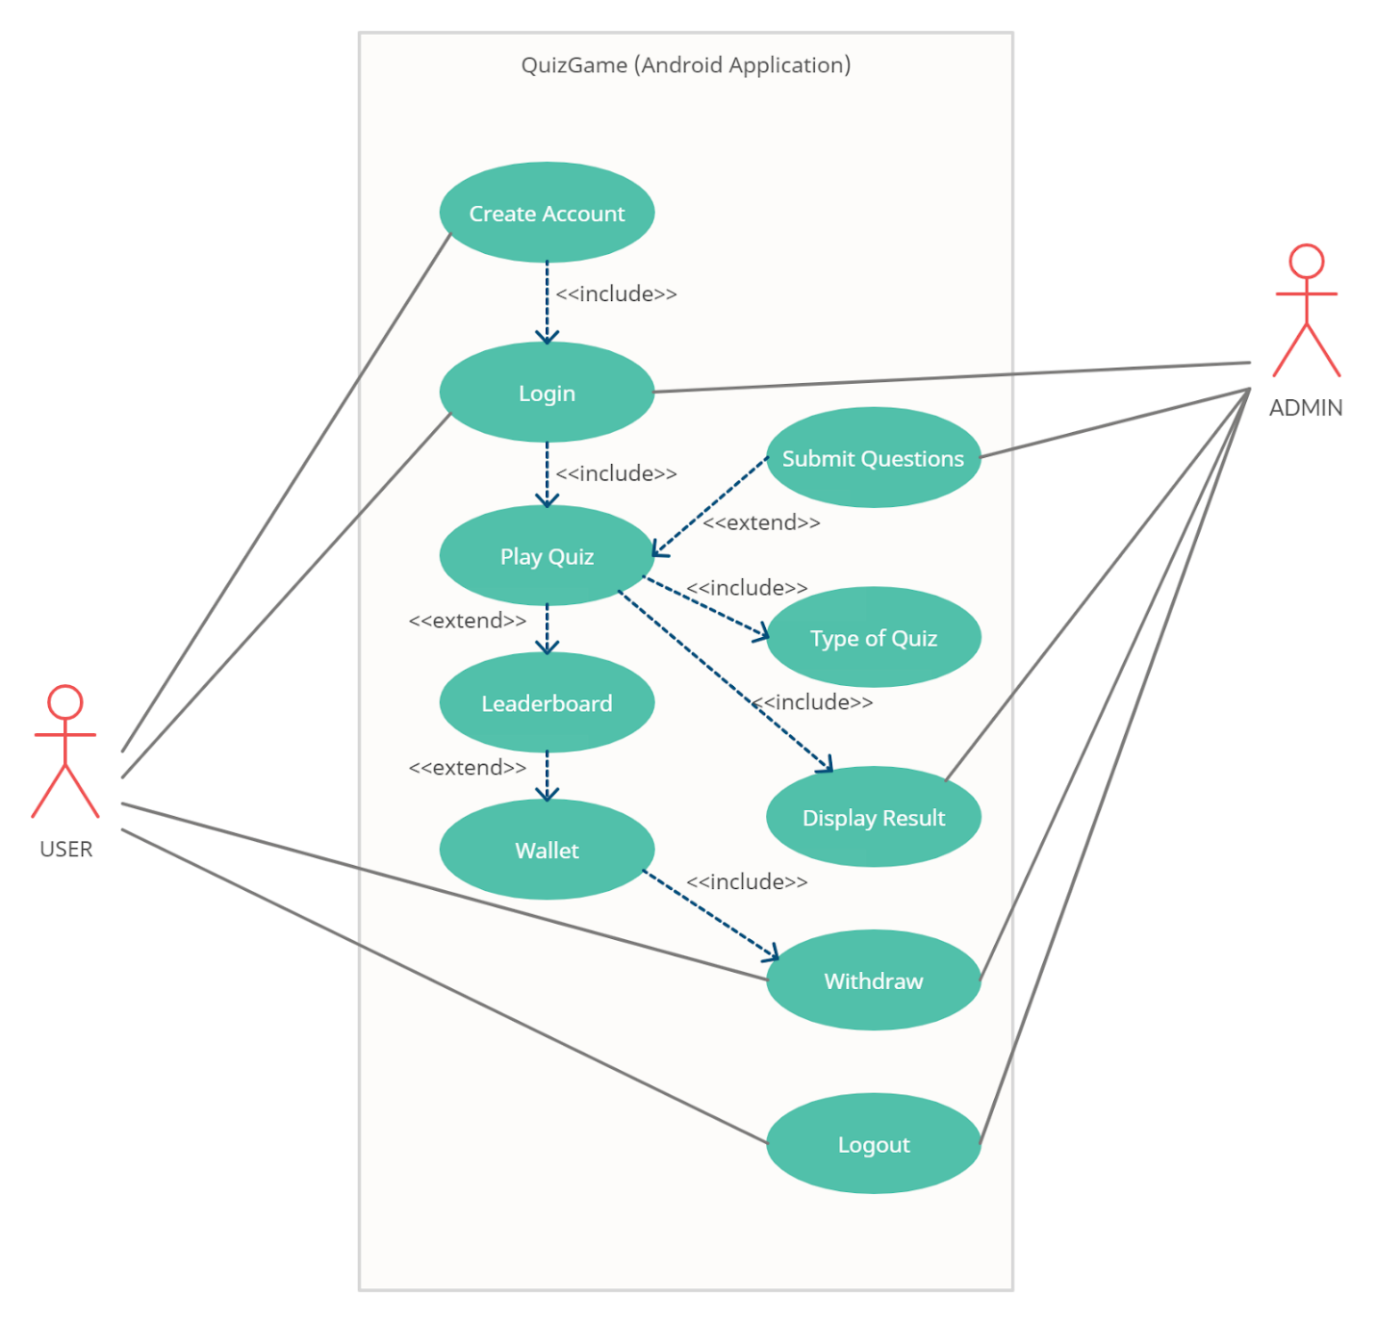

**2.4 Module Specifications**

* Account Signup :-

User can create account using **email id** and **password**.

* Account Login :-

User can login using **email id** and **password**.

* Categories :-

These are the topics of the quiz.

* Quiz Window :-

It displays questions with its options.

* Result  :-

It is the result of the quiz.

* Leaderboard:-

It is rank wise presentation of all the users using the app.

* Wallet:-

Contains total coins and withdraw option.

* Profile :-

Displays information about current user and a logout option.

**2.5 User Interface Design ( Screen Layouts)**

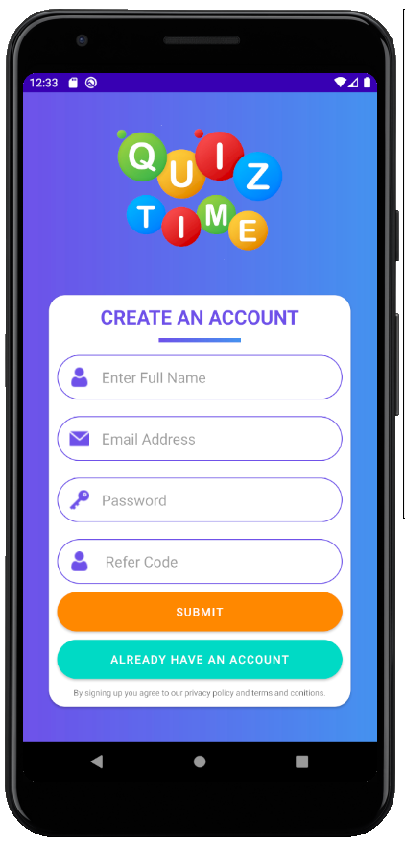

**Signup Screen:**

To create an **user account**

and **sign in** to the system.

**--------------------------------------------------------------------------------------------------------------------------**

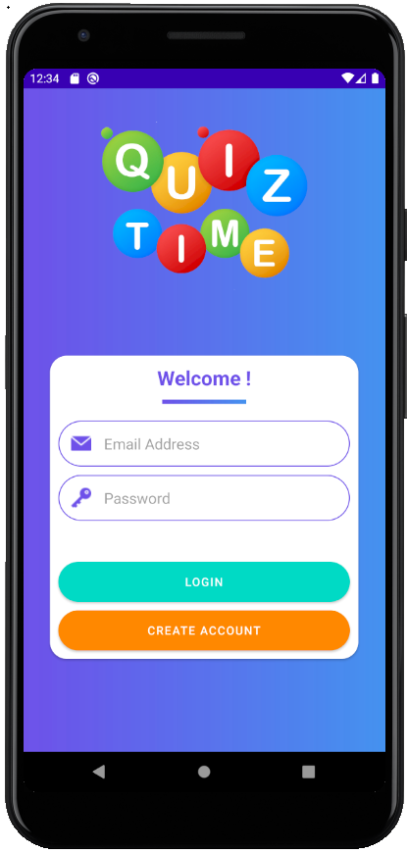

**Login Screen:**

To **log in** to the system with

existing account.

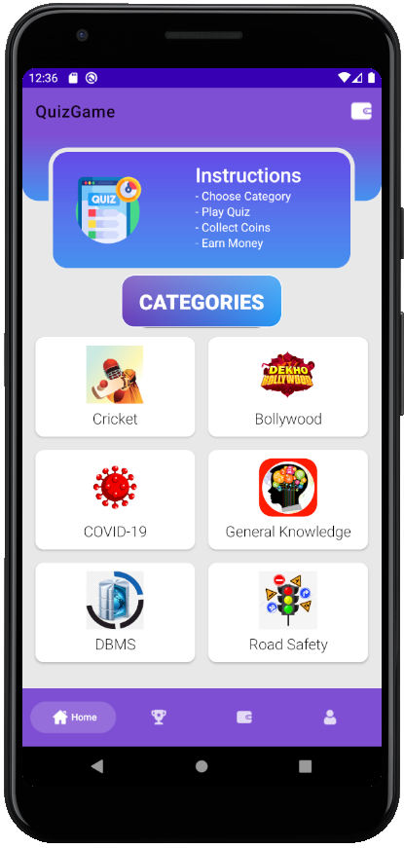

**Home Screen:**

A window which displays

quiz **categories** and a **menu bar**

to navigate through the app.

--------------------------------------------------------------------------------------------------------------------------------

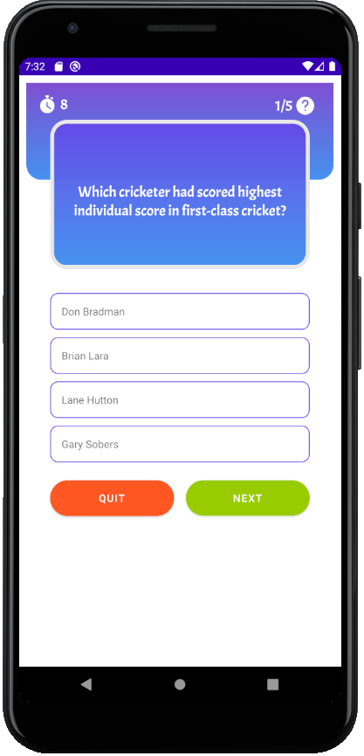

**Quiz Screen:**

Displays **questions** according

to the chosen category.

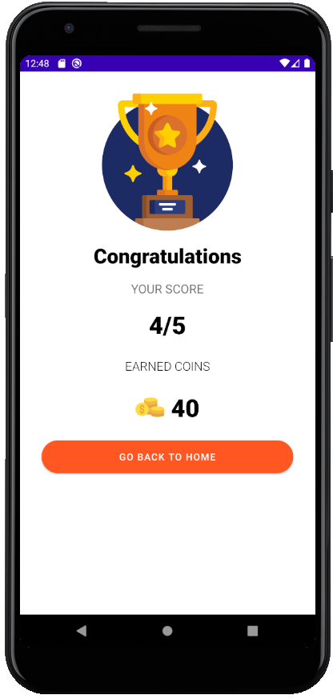

**Result Screen:**

Displays the **result** of Quiz

and **coins earned**.

--------------------------------------------------------------------------------------------------------------------------------

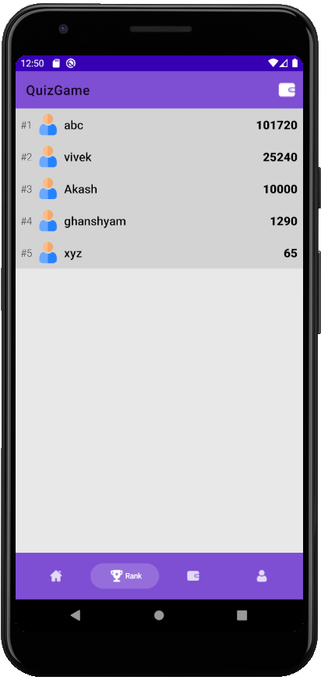

**Leaderboard Screen:**

Displays **Leaderboard**.

**Wallet Screen:**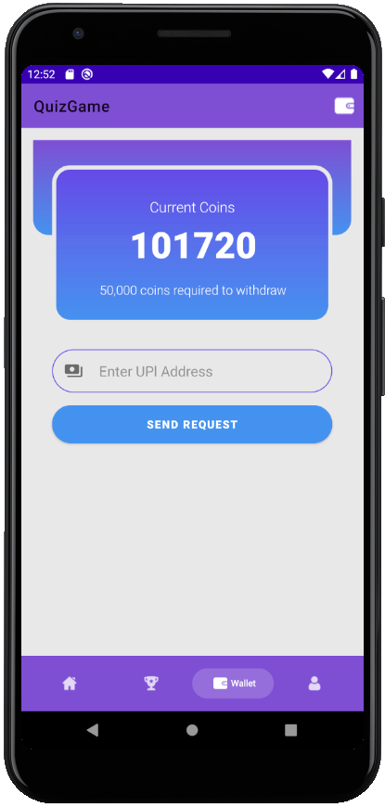

Displays **total current coins**

of the user.

And option to **withdraw**.

--------------------------------------------------------------------------------------------------------------------------------

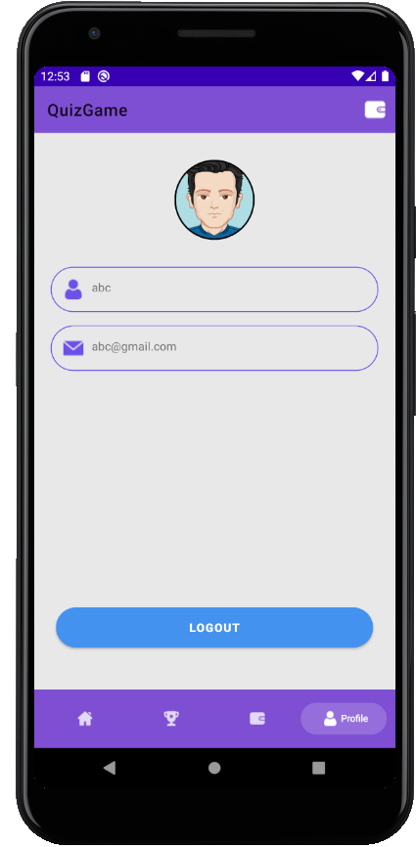

**Profile Screen:**

Displays current user **profile**

and **logout** option.

**3 . FUTURE SCOPE AND LIMITATION**

**Limitations of existing system**

1. Quiz Game Requires continuous internet connection. It is major drawback if user has bad or no network connectivity.
2. Quiz Game only works on android operating system, it is not a cross-platform application.
3. There is no time limit on how much time user spend on Quiz Game.

**Explain how would you eliminate these limitations**

1. Local database(SQLite) can be used to solve internet issues.
2. User who spend excessive time on app can be restricted for period of time.

**4 . CONCLUSION**

**4.1 The Application Achievements**

The application **Quiz Game** is a unique android application. The main objective of the project is achieved and can be used to help students get familiar with **MCQ** format. The other big feature of the application is that the user can withdraw money with the coins earned. These both are achieved using this application.

**4.2 What have we learned from this project?**

The application **Quiz Game** has been implemented successfully on different Android devices and this enhanced my confidence in Android development. This gave us an idea of Android Application Development, it helped us learn **Firestore** database and how to use **Firebase** in Android Development and we would like to learn more about its development in the coming days and we would like to try and develop more apps in Android.

**5 . BIBLIOGRAPHY**

<https://firebase.google.com/docs>

<https://developer.android.com/docs>

<https://www.flaticon.com/>

<https://www.lucidchart.com/pages/>